Map
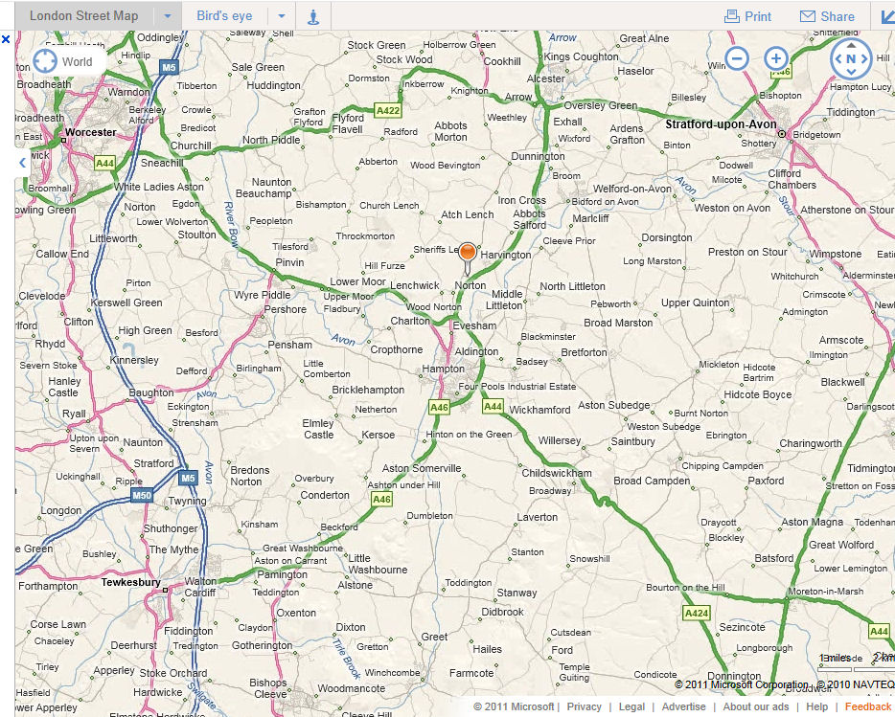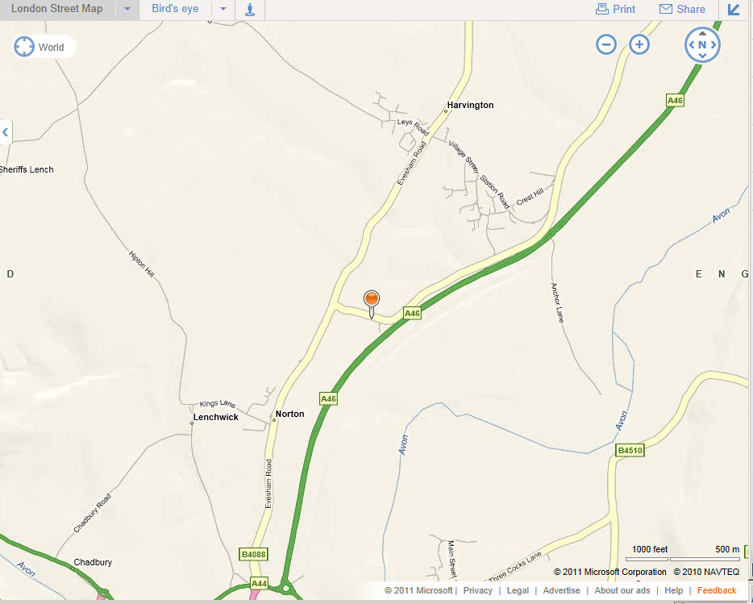

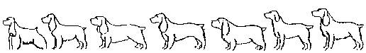UNITED SPANIEL ASSOCIATION
S C H E D U L E

OF SHOW GUNDOG QUALIFYING DAY

For AV Spaniels
(EXCLUDING IRISH WATER SPANIELS)

on

4th November 2016

AT

New Farm, Norton, Nr. Evesham, Worcs
WR11 4TN
At the Kind permission of Norman Onens

JUDGES: Mr Steve Bolton [1984]
Mr Chris Page [NP]

Entries to: Shula M Shipton
121 Malvern Street
Stapenhill
Burton-on-Trent
Staffs
DE15 9DZ
Mobile 07540 098879
mishules@sky.com

Entries Close: 26th October 2016
Meet at 9.00 for 9.30 Start

QUALIFICATION
A gundog which has won a Challenge Certificate or previously qualified for Crufts through a breed class may be entered for a Show Gundog Working Certificate at a Field Trial or a Show Gundog Working Day for its sub-group, licensed by the Kennel Club, with a minimum of two Judges officiating, of which at least one must be an A Panel Judge.

The Show Gundog Working Qualifying Day is limited to 20 Dogs. A draw will take place on 28th October 2016. For results of the draw a SAE is required.

When entering more than one dog, PLEASE place dogs in order of preference.

Regulations J(F)7
Before signing a Certificate the Judges must be satisfied that the dog fulfilled the following requirements:-
- The dog has been tested in line.
- The dog has shown that it is not gunshy.
- For a Retriever, that it hunted for, and found, dead or wounded game, faced cover, and retrieved tenderly.
- For a Spaniel, that it hunted, faced cover, produced game and retrieved tenderly.
- For a Pointer or Setter that it hunted and pointed game.
- For a Hunt, Point and Retrieve Breed that it hunted, pointed game and retrieved tenderly.
- For all retrieving breeds, that the dog entered water freely, swam and retrieved. [If a natural retrieve from water is not possible then a dummy may be used and if suitable water is not available the dog is permitted to undertake a Special Water Test as soon as possible after the day, but between 1 September and 1 April, which will be recognised by the issue of a Certificate, to be signed by two Field Trial Panel Judges, one of whom must be on the “A” Panel.]
- That the dog has not whined or barked in line, subject to the Breed Standard.
- That the dog has been under reasonable control, absolute steadiness is not essential.

Please clean up after you and your dog. Thank you.

Entry Fees: £30.00 per dog per test.

Cheques Payable to United Spaniel Association

There will be a raffle during lunch. Prizes would be warmly welcomed

Dogs should not be left in cars in high temperatures

DIRECTION TO NEW FARM, NORTON WR11 4TN

From the South

Take A46 around Evesham till you reach large roundabout with petrol station and shop on your right, take the 1st turning off the roundabout signposted Worcester A44, Pershore A4104, then immediately go around small roundabout take 3rd turning signposted B4088 Norton and Harvington. Follow that road through Norton to small roundabout (Norton grange pub is on your left) take 2nd turning signposted Bidford, then about 300 yards look for the fishing sign on your left (black sign with three white x’s on) turn right and you will go over the bridge, then turn right and follow the road towards the house. Parking will be notified as you approach the house.

From the North

Take the A46 towards Evesham till you reach large roundabout with petrol station and shop on your left take the 3rd turning signposted Worcester A44, Pershore A4104 and follow directions as above.

UNITED SPANIEL ASSOCIATION  ID NUMBER: 1344 |  |  |  | SHOW GUNDOG WORKING DAY |  |  |  |  | Entries Close: 28th October 2016
INSTRUCTIONS This form must be used by one person only (or partnership). Writing MUST BE IN INK AND BLOCK CAPITALS  Use one line only for each dog. The name of the dog and all the details as recorded with the Kennel Club must be given on this entry form. If an error is made the dog may be disqualified by the Committee of the Kennel Club. ENTRIES FOR FIELD TRIALS WILL ONLY BE ACCEPTED FROM GUNDOGS REGISTERED AT THE KENNEL CLUB IN THE GUNDOG GROUP (vide Reg. J1.a.,J7a & B20) and if a registered dog has changed ownership the TRANSFER must be applied for before the closing of entries.  When entering more than one breed or variety, use if possible a separate form for each. On no account will entries be accepted without fees. |  |  |  |  |  |  |  |  | Entry Fees  £30.00 per dog
 | REGISTERED NAME OF DOG  (BLOCK CAPITALS) |  | KENNEL CLUB  REG NO., STUD  BOOK NO. OR ATC NO. |  | FULL DATE  OF BIRTH | BREEDER |  | SIRE  (BLOCK LETTERS) |  | DAM  (BLOCK LETTERS)
1

 |  |  | BREED |  | SEX
2
 |  |  | BREED |  | SEX
For Qualification see Schedule DATE |  | SHOW |  |  |  |  | Name of Owner(s) (In block letters)
1 |  |  |  |  |  |  | ADDRESS
2 |  |  |  |  |  |  | Telephone No Email
ONE LINE FOR EACH DOG CHECK ALL DETAILS BEFORE POSTING  DECLARATION  I/We agreed to submit to and be bound by the Kennel Club Ltd Rules and Regulations in their present form or as they may be amended from time to time in relation to all canine matters with which the Kennel Club is concerned and that this entry is made upon the basis that all current single or joint registered owners of this dog(s) have authorised/consented to this entry.  I/We also undertake to abide by the Regulations of this Trial and not to bring to the Trial any dog which has contracted or been knowingly exposed to any infectious disease during the 21 days prior to the day of the Trial, or which is suffering from a visible condition which adversely affects its health or welfare. I also declare that I am fully conversant with the Field Trial Regulations and have studied the Guide to the Conduct of Field Trials.  I/We further declare that, I believe to the best of my knowledge that the dogs are not liable to disqualification under Kennel Club Field Trial Regulations.  Usual Signature of Owner(s)………………………………………………………………………………... Date …………………………….  Note: Dogs entered in breach of Kennel Club F.T. Regulations are liable to disqualification whether or not the owner was aware of the breach. |  |  |  |  |  |  | Entries and Fees which MUST BE PREPAID to be sent to  Shula M Shipton  121 Malvern Street, Stapenhill, Burton-on-Trent, Staffs. DE15 9DZ  07540 098879 mishules@sky.com  ______________________________________________________  Name Of Handler (In block letters)  ADDRESS  Telephone No email

